**Inventory Management System**

**Pre-requisites:**

* ✔️ Git installed and configured with SSH or Personal Access Token (PAT)
* ✔️ Python installed (preferably 3.x)
* ✔️ Azure DevOps account with a new project created
* ✔️ Your **local project folder** contains:
  + check_reorder.py
  + final_inventory_dashboard.csv
  + azure-pipelines.yml

**Step 1: Create Python and YAML Files**

**1. Python Script (check_reorder.py)**

import pandas as pd  
  
# Load the inventory CSV file  
df = pd.read_csv("final_inventory_dashboard.csv")  
  
# Filter only products that need reorder  
reorder_df = df[df["reorder_flag"] == "REORDER"]  
  
# Save the result to a new CSV file  
reorder_df.to_csv("reorder_report.csv", index=False)  
  
print("reorder_report.csv generated successfully.")

**⚙️ 2. Azure DevOps Pipeline File (azure-pipelines.yml)**

trigger:

  schedule:

    - cron: "0 7 * * *"  # Runs daily at 7 AM UTC

      displayName: Daily 7AM run

      branches:

        include:

          - main

      always: true

pool:

  vmImage: 'ubuntu-latest'

steps:

  - task: UsePythonVersion@0

    inputs:

      versionSpec: '3.10'

      addToPath: true

  - script: |

      python -m pip install --upgrade pip

      pip install pandas

    displayName: 'Install Dependencies'

  - script: |

      python check_reorder.py

    displayName: 'Run Reorder Check Script'

  - task: PublishBuildArtifacts@1

    inputs:

      PathtoPublish: 'reorder_report.csv'

      ArtifactName: 'ReorderReport'

      publishLocation: 'Container'

    displayName: 'Publish Reorder Report Artifact'

**Step 2: Create a New Azure DevOps Project**

1. Go to <https://dev.azure.com/>
2. Click **"New Project"**
3. Give it a name like Inventory_Management_System
4. Set Visibility: Private
5. Click **Create**

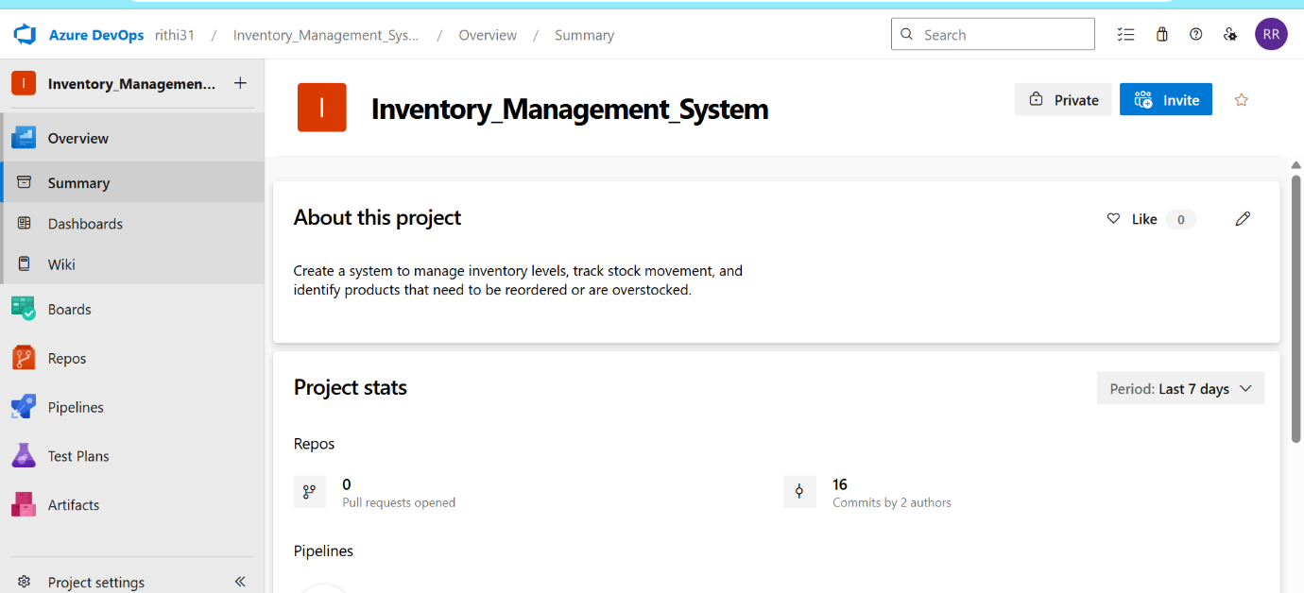

**Step 3: Push Local Project to Azure Repo via SSH**

**In PowerShell:**

cd "C:\Users\anith\OneDrive\Desktop\Inventory_Management_System\Inventory_Management_System-2"

git init

git remote add origin

git@ssh.dev.azure.com:v3/rithi31/Inventory_Management_System/Inventory_Management_System

git add .

git commit -m "Initial commit"

git push -u origin main

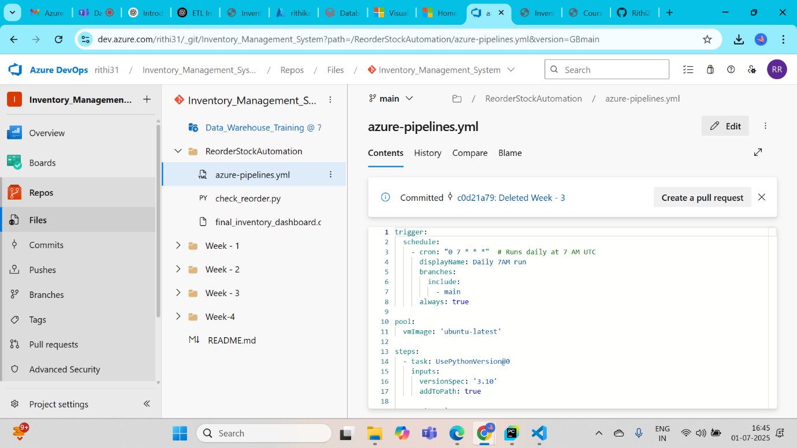

**Step 4: Configure and Run Azure Pipeline**

1. Go to your **Azure DevOps project**
2. Click **Pipelines → Create Pipeline**
3. Choose:
   * **Azure Repos Git**
   * Select your repository
   * **"Existing Azure Pipelines YAML file"**
4. Choose:
   * Branch: main
   * Path: /azure-pipelines.yml
5. Click **Continue**, then **Run Pipeline**

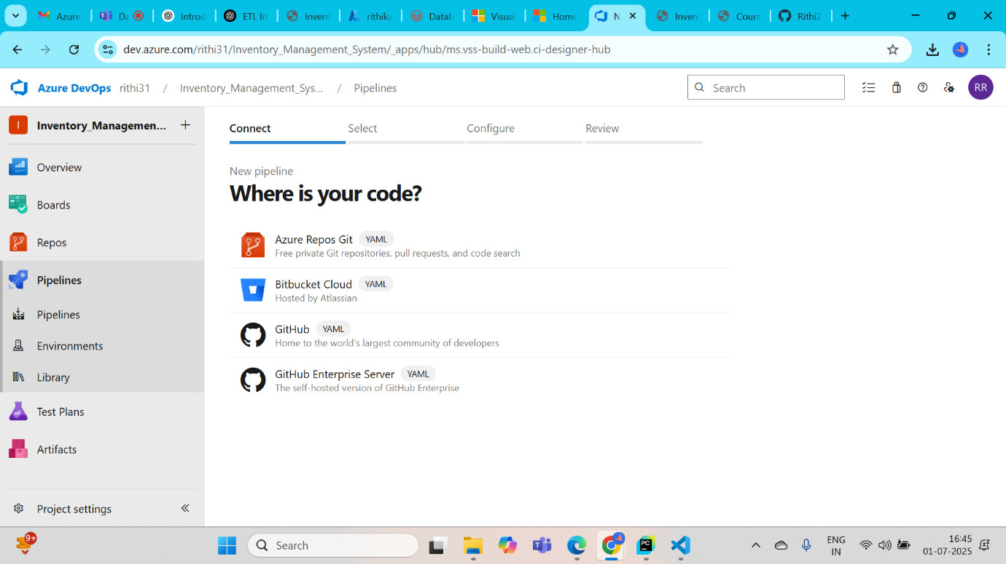

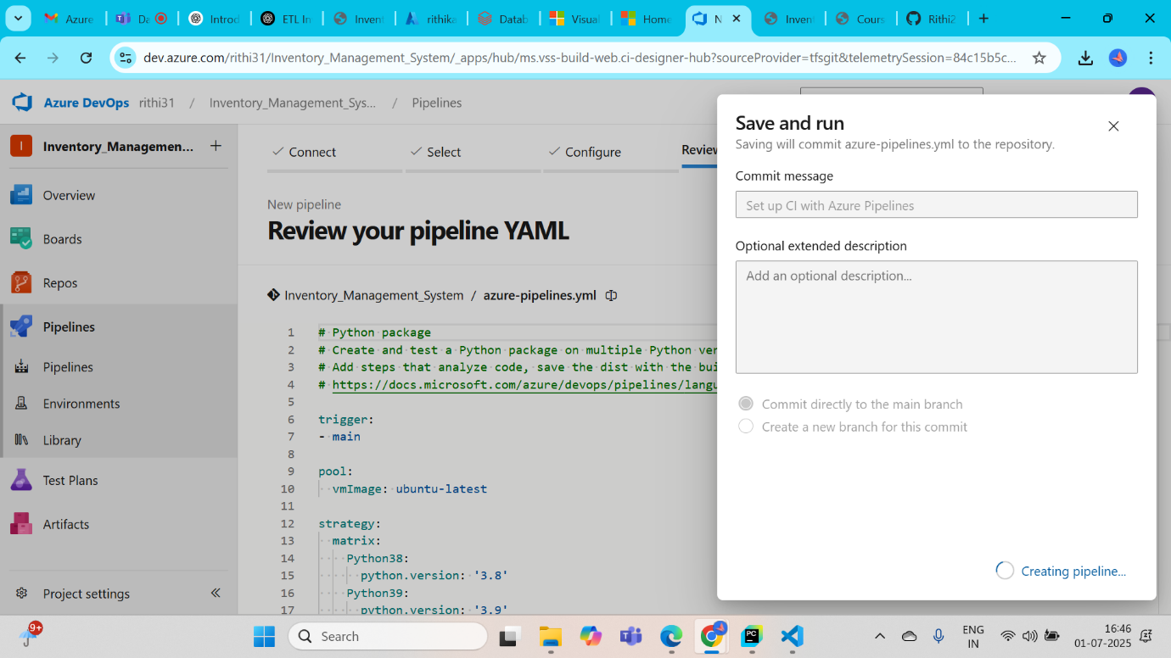

**Step 5: Final Output**

* The pipeline will:
  + Install dependencies
  + Run the reorder script
  + Save reorder_report.csv

